Hickory Creek Elementary School
SAC Minutes
September 7, 2021

Meeting was held in Media Center as well as virtually through Microsoft Teams. Shauna Smalling called the meeting to order at 4:02pm
12 were in attendance: Shauna Smalling (via Microsoft Teams), Mrs. Gary-Donovan (subbed in for Mrs. Cubero-Gonzalez), Jillian Ferro, Jennifer Brant (via Microsoft Teams), Amy DeRoo, Laura Eads (via Microsoft Teams), Chrissy Tarpey, Stephanie Kluge (via Microsoft Teams), Raquel McAlee (via Microsoft Teams), Jeremy McAlee, Jennifer Tarrant (via Microsoft Teams), and Rebecca England (via Microsoft Teams).
Jennifer Bryant made a motion to open the meeting and Jeremy McAlee seconded it.
The minutes from our May 4, 2021 meeting had not been submitted yet. Chrissy Tarpey will get them to Shauna Smalling and they will be reviewed at the next SAC meeting on October 5, 2021.
Shauna Smalling discussed the role of SAC and the schedule of when the meeting will be held this school year. She also spoke with Mrs. Cubero-Gonzalez about sending out more information about SAC to HCE families and invite any that are interested to attend a meeting and join if they so choose.
Raquel McAlee presented the Treasurer’s Report. There are some discrepancies with what the current balances are. Raquel is waiting for Chris Southworth to give her this year’s beginning numbers based on whatever the district gave towards SAC for this school year. No bonuses were given for this school year. Everyone in attendance agreed to push this treasurers’ report to the next meeting on October 4, 2021 to give adequate time to Chris Southworth to get the figures to Raquel and then they will be reviewed and voted on at that time.
Chrissy Tarpey asked what the status was on the iPads and iPad covers that were purchased by SAC towards the end of last school year. Frank Nunez is still in the process of getting all of the new iPads set up with the proper software. He also discovered that the wrong cases were ordered and is working with Chris Southworth to see if they can be exchanged for the correct ones. Once all of that is taken care of, they will be dispersed to the various grades where needed.

Shauna Smalling had all of the current SAC members do a brief introduction of themselves for the new people present and then had the new people in attendance do the same. Jillian Ferro is interested in joining SAC as the co-chair. Amy DeRoo would like to join as a parental member. As the by-laws state, only instructional staff can vote to approve new instructional staff members and only parental members can vote to approve new parental members and so two separate motions were made. The first motion to approve Jillian Ferro as co-chair was made by Laura Eads and was seconded by Jennifer Bryant. All were in favor and the motion was approved. The second motion to approve Amy DeRoo as a parental member was made by Chrissy Tarpey and was seconded by Jennifer Tarrant. All were in favor and that motion was approved as well.

At this time, nobody present had any suggestions of amendments to the current by-laws and so no vote was required for this.

Shauna Smalling stated that the current Membership Form is due to the district on October 22, 2021 and so that form will be reviewed and voted on at the October 5, 2021 meeting in case anyone else chooses to join before that. A support staff member is still needed but so far nobody has come forward to fill that position.

Shauna Smalling talked about the budget for the 2021-2022 school year and informed everyone that as of that moment, no one has submitted a funds request. She stated that she will send out a reminder to staff as to how to go about submitting a request.

Mrs. Smalling mentioned that the School Improvement Plan (SIP) will be presented in October by Mrs. Cubero-Gonzalez. Various subgroups will be the focus and added into the SIP. Further discussion on this matter will be done in October.

The Principal Update was read by Mrs. Gary-Donovan who was filling in for Mrs. Cubero-Gonzalez. A copy of the report will be added to these minutes as an attachment. The principal update will be a new addition on the agenda for every SAC meeting this school year and will also be attached to the minutes of each month’s minutes.
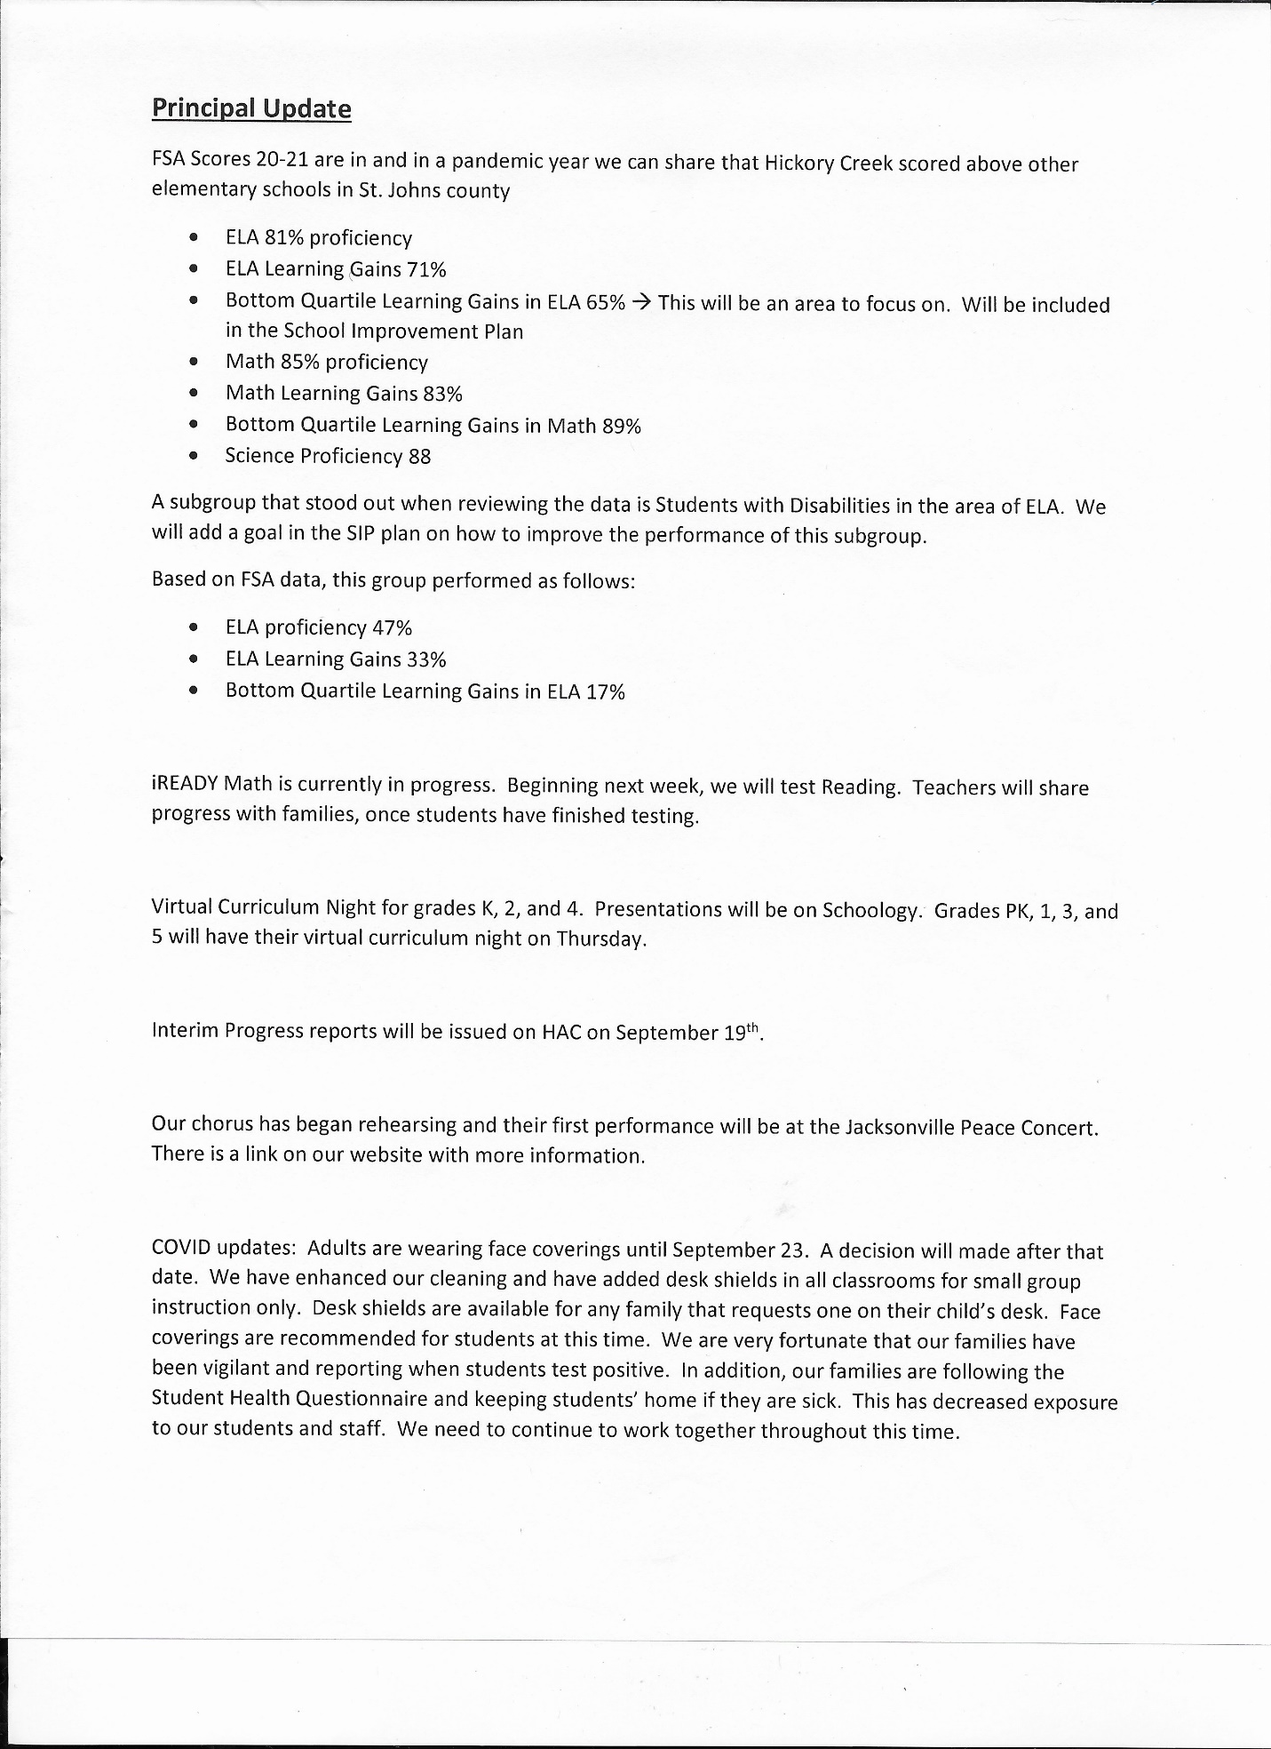

Stephanie Kluge reminded those present to bring any new budget thoughts or ideas to the next month’s meeting.

The next meeting will be held on October 5, 2021 at 4pm in the media center as well as virtually on Microsoft Teams.

Jillian Ferro made a motion to adjourn the meeting. Jeremy McAlee seconded the motion. Shauna Smalling called for a vote and the majority of those present approved the motion.

Meeting adjourned at 4:49pm

