Week at the Creek
October 23, 2023
Hawk families,  As flu season approaches, it is very important to follow the SJCSD illness and prevention guidelines. Please do not send a student to school if the have any of the following symptoms:  - Fever of 100.4 or greater  - Chills  - General tiredness or not feeling good  - Frequent congested (wet) or croup-sounding cough  - Lots of nasal congestion with frequent blowing of nose  - Vomiting (even just once)  - Diarrhea  - Stomach pain that is accompanied by repeated vomiting or diarrhea. Note: if you child complains of stomach pain for several days, your should call your doctor for advice.  - Symptoms of cold or flu  Our students and staff thank you for your help in keeping everyone healthy! | October  10/24 Report Cards Issued (on HAC)  10/27 Play with Words Day (Fifth Grade)  10/30 Character Counts Celebration  10/31 Storybook Character Day (PK-5)  November  11/3 PTO Monthly Meeting @ 3:30PM  11/7 SAC Meeting @ 4:00PM  TBD Veteran’s Day Chorus Performance  11/10 NO SCHOOL: Veteran’s Day  11/15 Fund Run  11/16 Interim Reports Issued (on HAC)  11/17 Picture Retakes  11/22-11/24 NO SCHOOL: Thanksgiving
Lunch Menu for Week of 10/23  Breakfast is $1.75; Lunch $3.25  Monday  - Chicken Slider Biscuit OR  - French Toast Sticks  Tuesday  - Penne Pasta w/ Marinera Sauce or Meatballs OR  - Chicken Nuggets  Wednesday  - Chicken Sandwich OR  - Pepperoni Calzone  Thursday  - Cheese Pizza OR Pepperoni Pizza OR  - Mini Corn Dogs  Friday  - Hamburger or Cheeseburger OR  - Max Cheese Sticks  Please visit our website for additional information on our Cafeteria policies, monthly menus, and additional purchase options. | HCE Lunch Visits  October Lunch Visits  Please know that to participate you MUST be a cleared volunteer. If you have not had a chance to fill out our access form, please do so now at:  https://www.stjohns.k12.fl.us/volunteer/.  Please follow the directions on the HCE Lunch Visit sign up. Once you are done with your lunch visit, please exit the building through the main office.  We look forward to your visit.

HCES PTO NEWS

Home Access Center

The Home Access Center (HAC) is a web-based application and where you will find transportation information, student data, student grades, and how you will access your student’s report card.
Please visit the website below to access to sign up for an account: https://www.stjohns.k12.fl.us/hac/.

Story Book Character Day: PK-5
On Tuesday, October 31st students are welcome to wear a costume based on a storybook character. The student MUST bring the book with them. Costumes may be store bought or homemade; get creative! All costumes MUST follow dress code. NO MASKS or FULL-FACE PAINT ALLOWED. Please note that students will still participate in recess and PE, costumes should be comfortable and appropriate for a full, active school day.

Play with Words Day: 5th Grade
On Friday, October 27th students in 5th grade will dress up as an idiom or vocabulary word. Costumes may be store bought or homemade; get creative! Fifth grade teachers will share more information. Please note that all costumes MUST follow dress code. NO MASK or FULL-FACE PAINT ALLOWED. Please note that students will still participate in recess and PE, costumes should be comfortable and appropriate for a full, active school day.

Character Counts! Celebration
Every month we will celebrate one student per class that demonstrates the monthly Character Counts! pillar. This month we will celebrate Responsibility. The teacher and students will nominate a candidate. Families will receive an invite to attend our celebration.

Red Ribbon/Bully Prevention Week
Monday  October 23 | Tuesday  October 24 | Wednesday  October 25 | Thursday  October 26 | Friday  October 27
Color the World With Character by being Drug and Bully Free  Wear Tie-Dye | From Head to Toe, I Make Responsible Choices!  Wear Crazy Socks | My Character Counts – Hats Off to Being Drug and Bully-Free.  Wear your favorite hat | Team Up for a Healthy Lifestyle So We Can All Be Drug and Bully-Free.  Wear your favorite sports team shirt | We can Inspire Others with Our Positive Attitude.  Wear a red shirt to say no to drugs
Veteran’s Day
Wall of Honor
HCE is honored to recognize Veterans and active military family members. Please use the template attached to the Week at the Creek email. Complete the template and send to your student’s teacher. We will create a Wall of Honor in our main hallway.
Please note, in order to sign-in to our lobby computer as a volunteer, you MUST be a cleared volunteer and you MUST have a driver’s license. Please follow the directions posted on the computer to sign in.  Ruth, our receptionist, can also help.  Please visit our site regarding school access:  https://www-hce.stjohns.k12.fl.us/ | 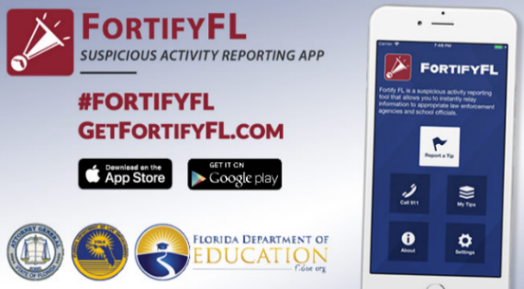

MEDIA CENTER CORNER
To access our SSYRA Lists:
SSYRA Junior Book List (K-2) SSYRA Book List (3-5)
Search library catalog here: | Submit a purchase recommendation here: | Access Individualized library plan Info here:
Absences
A written note is needed within 48 hours of returning to school stating the cause of the absence.
Excused absences include: personal illness, illness of an immediate family member, a death in the family, religious holidays of the student’s established religious faith, required court or law agency appearances, public functions, state competitions, scheduled doctor or dentist appointments*.
Unexcused absences include: shopping trips, pleasure trips**, suspension from school, appointments without prior approval except in case of emergency, truancy, and other avoidable absences.
For a complete list of excused and unexcused absences, refer to page 18 in the
Student Code of Conduct.

