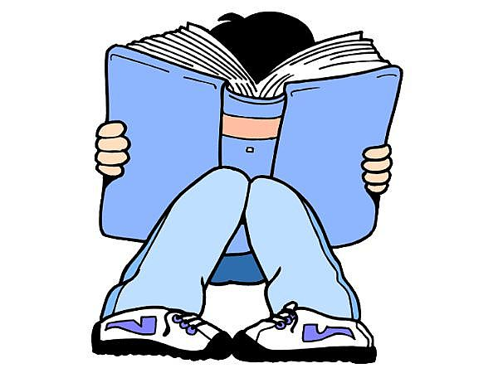
Rising 4th and 5th Grade
Book Recommendations

**2019-2020 Sunshine State Books**
Ana Maria Reyes Does Not Live in a Castle by Hilda Eunice Burgos | The Girl Who Drank the Moon by Kelly Barnhill
Aquicorn cove by Katie O’Neill | Far Away by Lisa Graff
The Cardboard Kingdom by Chad Sell | The Story Web by Megan Frazer Blakemore
Clayton Byrd Goes Underground | Series:
Flying Lessons & Other Stories by Ellen Oh | Camp Average by Craig Battle
Front Desk by Kelly Yang | Potion Masters by Frank L. Cole
Hello, Universe by Erin Entrada Kelley | Artemis Foul
The House That Lou Built by Mae Respicio | Wizard for Hire by Obert Skye
Knights vs. Dinosaurs by Matt Phelan | The Babysitters Club by Raina Telgemeier
Love Sugar Magic: A Dash of Trouble by Anna Meriano | Big Nate by Lincoln Peirce
Makoons by Louise Erdich | Who was…?
Rocket to the Moon! Big Ideas That Changed the World #1 by Don Brown | What was…?
Waste of Space by Stuart Gibbs | Story Thieves by James Riley
We’re Not from Here by Geoff Rodkey | Secret Coders by Gene Luen Yang
Illegal by Eoin Colfer | Unicorn Rescue Society by Adam Gidwitz
Red’s Planet by Eddie Pittman | The Spiderwick Chronicles by Tony DiTerlizzi
The Time Museum by Matthew Loux | I Survived books by Lauren Tarshis
Spark by Sarah Beth Durst | The Library of Ever by Zeno Alexander
City on the Other Side by Mairghread Scott | Girls Who Code
Planet Earth is Blue by Nicole Panteleakos | Nick and Tesla by Bob Pflugfelder and Steve Hockensmith
Black Panther: The Young Prince by Ronald L. Smith | Baseball Card Adventure

