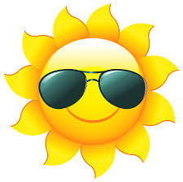
Summer Reading BINGO
Rising 4th and 5th Grade
Read a book that has received the Caldecott or Newbery Medal | Read an SSYRA book | Read a book by your favorite author | Read a chapter book | Read a nonfiction book about the ocean or an ocean creature
Read a fantasy book | Read in a fort you made | Make a robot out of Legos and write about your robot | Read in the pool or on the beach | Read a book by Kwame Alexander or Jacqueline Woodson
Read a book that is also a movie | Write your own story | Visit the Public Library | Read to someone who can’t read | Play the license plate game in the car
Read a historical fiction book and write a few facts about the topic | Read outside | Read a graphic novel | Create a Venn Diagram comparing and contrasting oceans and rivers | Read a magazine
Make a list of fun things to do this summer | Read with a flashlight | Make a card for someone | Have a reading party with family or friends (with treats) | Find a nonfiction book about a place you visited this summer

