Book Recommendations for
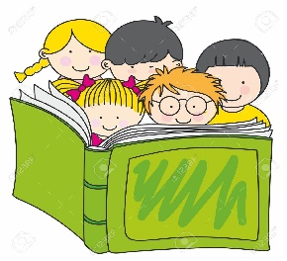
Rising Kindergarteners and 1st Graders
Below is a list of books that correspond with the kindergarten and 1st grade BINGO summer reading program. The list includes books that children can begin reading independently, great picture books for read alouds, and specific authors for this age group.
Recommended Books to be read aloud: Independent Readers:
My Papi has a Motorcycle by Isabel Quintero | Fox and Chick The Quiet Boat Ride and Other Stories by Sergio Ruzzier
Rosie Revere, Engineer by Andrea Beaty | Flop to the Top by Eleanor Davis
Because by Mo Willems | Elephant and Piggie The Thank you Book by Mo Willems
A Piglet Named Mercy by Kate DeCamillo | Monkey and Cake This Is My Fort by Drew Daywalt
Bright Sky, Starry City by Uma Krishnaswami | Harold and Hog Pretend For Real! By Dan Santat and Mo Willems
Life on Mars by Jon Agee | Clara and Clem in Outer Space by Ethan Long
My Awesome Summer by P. Mantis by Paul Meisel | Let’s Go to the Moon by Erica Silverman
Hello by Fiona Woodcock | There was an Old Astronaut Who Swallowed the Moon! By Jared D. Lee
A Hundred Billion Trillion Stars by Seth Fishman | Monkey and Cake What Is Inside This Box by Drew Daywalt
Jabari Jumps by Gaia Cornwall | Mr. Monkey Takes a Hike by Jeff Mack
The Sun is Kinda Big Deal by Nick Seluk | Motor Mouse by Cynthia Rylant
The Most Magnificent Thing by Ashley Spires | The Adventures of Otto by David Milgrim
Hello Lighthouse by Sophie Blackall | Great Authors:
Dreamers by Yuyi Morales | Denise Fleming | Lois Ehlert
Dude by Aaron Reynolds | Drew Daywalt | Donald Crews
A First Book of the Sea by Nicola Davies | Ame Dyckman | Dr. Seuss
Alma and How She Got Her Name by Juana Martinez-Neal | Eric Carle | Mo Willems
Horrible Bear! By Ame Dyckman | Kevin Henkes | Audrey Wood
Goodbye Summer, Hello Autumn by Kenard Pak | Jane Yolen | Margaret Wise Brown
A Big Mooncake for Little Star by Grace Lin | Tana Hoban | Ashley Spires

