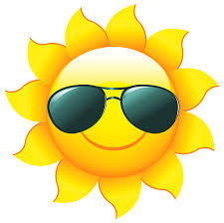
Summer Reading BINGO
Rising K and 1st Grade
Read to a stuffed animal | Make 10 sight words with magnet letters | Read an Eric Carle book | Write all the color words in a rainbow | Read a nonfiction book about the ocean
Read a book to your sibling | Read in a fort you made | Make a vehicle out of Legos and read a book about that vehicle | Read in the bathtub | Read a book by Ame Dyckman
Read a book that is also a movie | Write your own story | Visit the Public Library | Read to someone who can’t read | Write a sentence with 3 sight words
Read a book about summer | Read outside | Find 15 words you know in a newspaper | Make 10 CVC or CVCe words with stencils | Read a magazine
Use play-doh to make your first and last name | Read with a flashlight | Make a card for someone | Have reading party with family or friends (with treats) | Find a nonfiction book about a place you visited this summer

